**1. Given a two integer numbers return their product and  if the product is greater  
than 1000, then return their sum**

**Ans:-**

# -*- coding: utf-8 -*-

"""

Created on Sat Aug 6 22:18:43 2022

@author: Shilpa

"""

x=int(input("enter the number 1"))

y=int(input("enter the number 2"))

if x + y >1000 :

print("value are grater then 1000")

else :

print("number 1 and number2 sum is",x + y)

**2. Given a range of first 10 numbers, Iterate from start number to the end number  
and print the sum of the current number and previous number  
ans:-**

num = list(range(10))

previousNumber=0

for i in num:

sum=previousNumber+i

print('CurrentNumber ' + str(i) + ' previousNumber ' + str(previousNumber)+ ' sum is ' + str(sum))

previousNumber=i

**o/p:-**

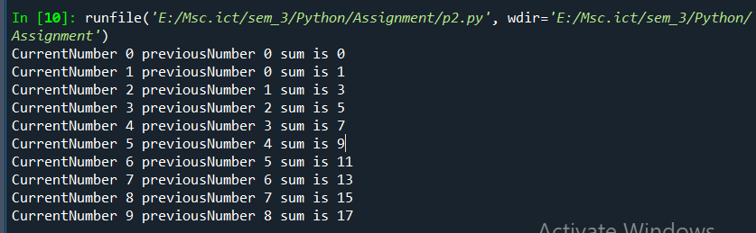

**3. Given a string, display only those characters which are present at an even index number. Dians**

**Ans:-**

**# -*- coding: utf-8 -*-**

**"""**

**Created on Sun Aug 7 07:01:22 2022**

**@author: Shilpa**

**"""**

**def printEventIndex (str):**

**for i in range(0,len(str)-1,2):**

**print("index [",i,"]",str[i])**

**inputstring=input("enter the string")**

**print("Original string is",inputstring)**

**print("event index chars display")**

**printEventIndex(inputstring)  
  
4. Given a list of numbers, return True if first and last number of a list is same**

**Ans:-**

list = [90, 100, 300, 420, 90]

if list[0] == list[-1]:

print('Result is True')

/else:

print('Result is False')

**o/p:-**

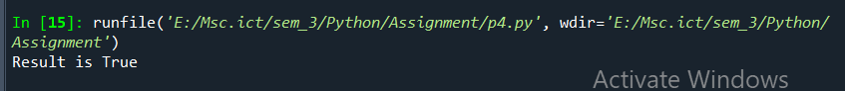

**5. Given a two list. Create a third list by picking an odd-index element from the first list and even index elements from second.**

**Ans:=**

# -*- coding: utf-8 -*-

"""

Created on Mon Aug 8 18:18:16 2022

@author: Shilpa

"""

list1 = [0, 1, 2, 3, 4, 5, 6,7]

list2 = [0, 11, 12, 13, 14, 15, 16,17]

res = list()

print("orignal first list",list1)

print("orignal second list",list2)

odd_elements = list1[1::2]

print("Element at odd-index positions from list one")

print(odd_elements)

even_elements = list2[0::2]

print("Element at even-index position from list two")

print(even_elements)

print("third list")

res.extend(odd_elements)

res.extend(even_elements)

print(res)

**o/p:-**

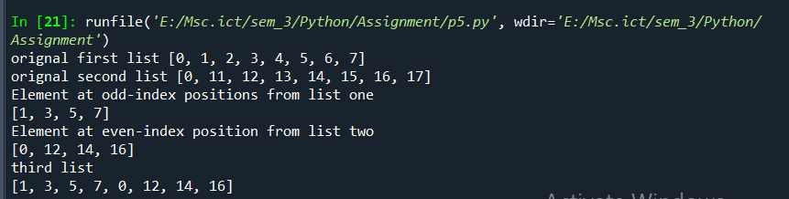 **6. Given an input list removes the element at index 4 and add it to the 2nd position and also, at the end of the list**

**Ans:-**

# -*- coding: utf-8 -*-

"""

Created on Mon Aug 8 18:41:26 2022

@author: Shilpa

"""

demolist=[16,12,2000,2001,22,1,2002,24,1,2004]

print("original list",demolist);

removelist=demolist.pop(4)

print("after remove element in the index4")

print(removelist)

demolist.insert(2,removelist)

print("element add in the second position")

print(demolist)

demolist.append(removelist)

print("after completed all..",demolist)

**o/p:-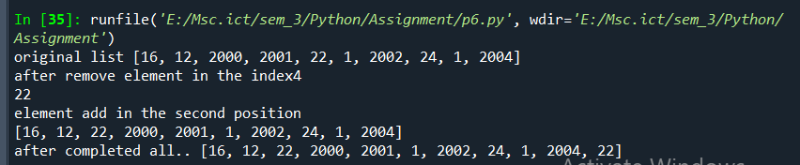 7. Given a list slice it into a 3 equal chunks and reverse each list**

**Ans:-**

# -*- coding: utf-8 -*-

"""

Created on Mon Aug 8 20:42:36 2022

@author: Shilpa

"""

sample_list = [11, 45, 8, 23, 14, 12, 78, 45, 89]

print("Original list ", sample_list)

length = len(sample_list)

chunk_size = int(length / 3)

start = 0

end = chunk_size

# run loop 3 times

for i in range(3):

# get indexes

indexes = slice(start, end)

# get chunk

list_chunk = sample_list[indexes]

print("Chunk ", i, list_chunk)

# reverse chunk

print("After reversing it ", list(reversed(list_chunk)))

start = end

end += chunk_size

**o/p:-**

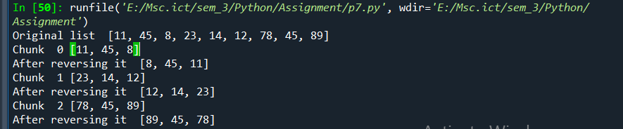

**8. Given a list iterate it and count the occurrence of each element and create a dictionary to show the count of each element  
Ans:-**

# -*- coding: utf-8 -*-

"""

Created on Mon Aug 8 22:04:47 2022

@author: Shilpa

"""

row=int(input("enter the number"))

for i in range(row):

for j in range(i+1):

print(j+1, end=" ")

print("\r") **9. Add a list of elements to a given set: {‘yellow’,’orange’} List:[blue,black]**

**Ans:-**

# -*- coding: utf-8 -*-

"""

Created on Mon Aug 8 20:20:20 2022

@author: Shilpa

"""

l_set={"yellow","orange"}

l_List=["blue","black"]

l_set.update(l_List)

print(l_set)

**o/p:-**

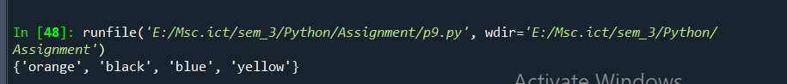 **10. Print the following pattern  
  
1  
1 2  
1 2 3  
1 2 3 4  
1 2 3 4 5  
o/p:-**

# -*- coding: utf-8 -*-

"""

Created on Mon Aug 8 19:11:23 2022

@author: Shilpa

"""

row=int(input("enter the number"))

for i in range(row):

for j in range(i+1):

print(j+1,end=" ")

print("\r") **11. calculate the sum of all number between 1 and given number**

# -*- coding: utf-8 -*-

"""

Created on Mon Aug 8 20:09:23 2022

@author: Shilpa

"""

num=int(input("enter the number:"))

sum=0

for i in range(1,num + 1):

sum += i

print(sum)  
 **12. Given a list iterate it and display numbers which are divisible by 5 and if you find number greater than 150 stop the loop iteration**

**Ans:-**

# -*- coding: utf-8 -*-

"""

Created on Mon Aug 8 20:33:37 2022

@author: Shilpa

"""

List1 = [12, 15, 32, 42, 55, 75, 122, 132, 150, 180, 200]

for i in range(0, len(List1), 1):

if List1[i]<=150:

if List1[i]%5==0:

print(List1[i])

**o/p:-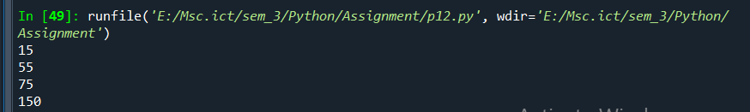 13. Reverse the following list using for loop  
  
List1 = [10,20,30,40]**

**Ans:-**

# -*- coding: utf-8 -*-

"""

Created on Mon Aug 8 19:41:03 2022

@author: Shilpa

"""

List1 = [10,20,30,40]

print("original list is ::::::",List1)

for i in reversed(List1):

print(i)

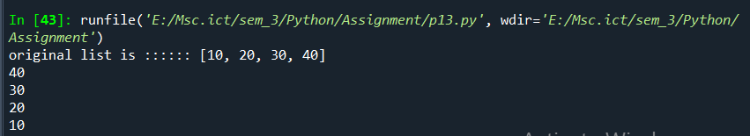

o/p:-

**14. Write a Python program to display all the prime numbers within a range**

**Ans:-**

lower=1

upper=5

print("prime numbers between",lower,"and ",upper)

for num in range(lower,upper + 1):

if num > 1:

for i in range(2,num):

if(num % i) == 0:

break

else:

print(num)

**op:-**

